1) Inspector Name:  RON ANTHONY  Inspector Code: 875 |  | 2) Inspection Date:  JUNE 18, 2025 |  |  |  | 3) Project Name (if any):  TABRIZ PETROCHEMICAL CO.
4) Scope of Inspection Required:
Inspection Notification No.: IDR-TPC-IN-NDF-9020
5) Inspection Address & Contact Info:
Company Name: M&M FREIGHT LLC
Address: DUBAI JEBEL ALI FREE ZONE
Contact Name: BIJESH Phone Number / Mobile Number: +971504676266 E-mail Address: NIL
6) Inspection Place:
Manufacturer Supplier Warehouse Port Customs Others Specify:
7) Client/Buyer:  TABRIZ PETRO CHEMICAL CO.  TEHRAN IRAN |  |  |  | 8) Vendor/Sub-Vendor:  NOBLAZE TRADING FZE  DUBAI UAE
9) Goods as Per Purchasing Documents:

SUPPLY OF F&G DEVICES AS PER PO NO. HDPE-16-DD-00-IN-PO-9020

10) Quality Inspection :
Visual | Dimensional check |  | Test |  | Doc’s Review 100%
%100  Spot Check | %100  Spot Check |  | %100  Spot Check
Random  No. of Items Checked: | Random  No. of Items Checked: |  | Random  No. of Items Checked:
11) Quantity Inspection :
Tally | Weight |  | Volume |  | Length |  | Others (Specify)
%100  Spot Check | %100  Spot Check |  | %100  Spot Check |  | %100  Spot Check
Random  No. of Items Checked: | Random  No. of Items Checked: |  | Random  No. of Items Checked: |  | Random  No. of Items Checked:
12) Brief Description of Packing:  Kind of Packing: WOODEN PALLET  Total Number of Packages: 3 PACKAGES  Total Net weight: - KGS  Total Gross weight: 482 KGS |  |  | 13) Shipping Mark (Please specify details in item 22):  PROJECT NAME: TABRIZ LLPE/HDPE PROJECT  L/C NO.  PO NO. HDPE-16-DD-00-IN-PO-9020  PACKAGE NO. 1-3  CONTENTS: F&G DETECTORS  WEIGHT: 163.50 KGS  DIMENSION: 120*80*94  MADE IN: UK
14) Means of Transport:
Truck Vessel Air Rail Combined
Shipment From: NO INFO Via: NO INFO To: NO INFO
15) Conclusion (Explain Briefly):
Stage (Inspection of the goods in this visit is satisfactory. Goods are released for further inspection)
Satisfactory (Inspection of the goods is satisfactory. Goods are released for shipment)
Non-Conformity (Discrepancies observed. Goods could not be released)
Abortive (Due to missing goods and/or documents, inspection could not be carried out)
Inspection completed? No Yes When No, Specify next insp. scope:
16) Documents Used for Inspection:
L/C No.: | No. of L/C Amendments: | P/I No.:
Tech. Spec. No.: | P/O No. / MR No.: | ITP No.:
Drawing No.: | Procedure No.: | Data Sheet No.:
Others:
Necessary Documents for Issuance of COI Has Been Collected: Yes No

17) Goods Inspected In Details:

SUPPLY OF 297 NOS. F&G DEVICES AS PER ATTACHED PL NO. REF. HDPE-9020-NDF-004
18) Order Completed? Yes No
Comments (If any):

19) Quality Inspection (Detailed description of quality inspection and assessment of quality control):
THE UNDERSIGNED INSPECTOR CARRIED OUT THE INSPECTION AT M&M FREIGHT WAREHOUSE LOCATED IN DUBAI JEBEL ALI FREEZONE CONDUCTED ON THE DATE OF 18/06/2025 WITH REFERENCE TO THE INSPECTION NOTIFICATION AND INSTRUCTION.

INSPECTED ITEMS AS PER SUBMITTED PACKING LIST: HDPE-9020-NDF-004

ITEM CODE | ITEM DESCRIPTION | QUANTITY (NOS)
CROWCON – U.K /  (IRMXBTAC011AF01) | EXPLOSION PROOF IR FLAMMABLE GAS DETECTOR  (FIXED IR DISPLAY TYPE) & HART – HEXANE – C6H14 | 81
CROWCON – U.K / S012130 | MOUNTING BRACKET KIT | 112
CROWCON – U.K / (IRMAX-BT-AC-011-AF-  03) | EXPLOSION PROOF IR FLAMMABLE GAS DETECTOR  (REMOTE DISPLAY TYPE) & HART – HEXANE – C6H14 | 24
CROWCON – U.K /  C011151/1 | IR DISPLAY – REMOTE VERSION | 24
CROWCON – U.K /  E07990 | 5-METER CONNECTION LEAD | 24
CROWCON – U.K /  S012169 | DUCT MOUNTING KIT | 24
CROWCON – U.K /(IRMAX-KN-AC-011-AF-  01) | EXPLOSION PROOF IR FLAMMABLE GAS DETECTOR WITH FIXED  IR DISPLAY & HART – PROPENE (PROPYLENE) – C3H6 | 4
CROWCON – U.K / (IRMAX-AE-AC-011-AF-  01) | EXPLOSION PROOF IR FLAMMABLE GAS DETECTOR WITH FIXED  IR DISPLAY & HART – ETHYLENE – C2H4 | 2
CROWCON – U.K /(IRMAX-KG-AC-011-AF-  01) | EXPLOSION PROOF IR FLAMMABLE GAS DETECTOR WITH FIXED  IR DISPLAY & HART– 1-BUTENE – C4H8 | 1
CROWCON – U.K / M041007 | CALIBRATION CAP (FOR IRGD) | 1

ACTIVITIES PERFORMED AND RESULTS AS PER ITP

ITP 2.3: EXPLOSION PROOF FLAMMABLE GAS DETECTOR

2.3.1 CHECK OF CATALOUGES:
-THE SUBMITTED DATA SPECIFICATION SHEETS AND CATALOUGES WERE VERIFIED BY INSPECTOR WITH SATISFACTORY RESULTS. THE ACTUAL ITEMS WERE COUNTER CHECKED AGAINST THESE DOCUMENTS WITH ACCEPTABLE RESULTS. THIS DOCUMENTS HAVE BEEN ATTACHED ON THE IR.

2.3.2 VISUAL CHECK:
-THE SUPPLIED INSTRUMENTS WERE FOUND IN BRAND NEW CONDITION WITHOUT ANY DAMAGES OBSERVED.
-TRACEABLE MARKINGS OF THE MANUFACTURER, MODEL NUMBERS, SERIAL NUMBERS AND COUNTRY OF ORIGIN CAN BE FOUND ON EACH SUPPLIED INSTRUMENTS, SS NAME TAGS WERE AFFIXED ON EACH UNIT.

2.3.3 QUANTITY CHECK:
-THE SUPPLIED QUANTITY AS PER ABOVE TABLE WAS VERIFIED AVAILABLE BY INSPECTOR. THE QUANTITY INSPECTED WAS FOUND IN LINE AS PER PACKING LIST WITH REFERENCE NO. HDPE-9020-NDF-004

2.3.4 CHECK OF ATEX CERTIFICATE:
-ORIGINAL DECLARATION OF CONFORMITY WITH ATEX COMPLIANCE AND GAS CALIBRATION REPORT CARD WITH CONTROLLED SERIAL NUMBERS CAN BE FOUND ON EACH GAS DETECTOR. THESE DOCUMENTS ARE ATTACHED ON EACH INTRUMENT INCLUDING INSTALLATION, OPERATING AND MAINTENANCE INSTRUCTION BOOKLET. THE INSPECTOR VERIFIED THESE DOCUMENTS AS ORIGINAL AND ACCEPTABLE.

2.3.5 PACKING AND MARKING:
-100% OF THE GAS DETECTORS INCLUDING F&G SPARES AND ACCESSORIES WERE KEPT AND SECURED IN 3 WOODEN PALLETS.

2.3.6 ISSUE SHIPPING RN:
HOLD POINT

ITP 3.5: (CALIBRATION CAP)
3.5.1 CHECK OF CATALOUGES:
-NOT APPLICABLE FOR THE ACCESSORIES

3.5.2 VISUAL CHECK:
-THE SUPPLIED ACCESSORIES WERE FOUND IN BRAND NEW CONDITION WITHOUT ANY DAMAGES OBSERVED.

3.5.3 QUANTITY CHECK:
-THE SUPPLIED QUANTITY AS PER ABOVE TABLE WAS VERIFIED AVAILABLE BY INSPECTOR. THE QUANTITY INSPECTED WAS FOUND IN LINE AS APER PACKING LIST WITH REFERENCE NO. HDPE-9020-NDF-004

3.5.4 PACKING AND MARKING:
- THIS ITEM WAS INCLUDED ON THE ACCESSORIES COMMODITIES AND HAS SECURED IN 1 OF THE 3 PALLETS.

3.5.6 ISSUE SHIPPING RN:
-HOLD POINT

100% OF THE INSPECTED ITEMS WERE FOUND IN BRAND NEW CONDITION WITHOUT ANY DAMAGES OBSERVED AT THE TIME OF INSPECTION, THE QUANTITY OF THE GOODS WERE VERIFIED AS WELL BY THE INSPECTOR WITH SATISFACTORY RESULTS. 100% OF THE QUANTITY INSPECTED WAS FOUND IN LINE WITH THE SUBMITTED PACKING LIST BY THE SUPPLIER.
297 NOS. OF F&G COMMODITIES INCLUDING ACCESSORIES WERE PACKED AND SECURED IN 3 WOODEN PALLETS IN QUANTITY, FINAL PACKING OF THE GOODS WERE CARRIED OUT AFTER THE INSPECTION, FINAL SHIPPING MARKING HAS SECURED AS WELL ON EACH PACKAGE.

THE FOLLOWING ITEMS WITH CONTROLLED SERIAL NOS. WERE UNPACKED ON EACH CARTON PACKAGE AND COC WAS VERIFIED BY INPECTOR, CONTROLLING EACH SERIAL NO. AGAINST EACH DOCUMENTS AND ITEM INSPECTED.

ITEM NO. | DESCRIPTION | SERIAL NO.
1. | IRMX-BT-AC-011-AF-01 (HEXANE ATEX) | W400834/01-019
2. | IRMX-BT-AC-011-AF-03 (HEXANE ATEX) | W400704/01-009
3. | IRMX-KN-AC-011-AF-01 (PROPYLENE ATEX) | W401283/01-002
4. | IRMAX-AE-AC-011AF (ETHYLENE ATEX) | W400269/01-001
5. | IRMX-KG-AC-011-AF-01 (BUTENE ATEX) | W400271/01-001

19-1) Marking on Goods as per specific requirements:
AS PER PHOTOGRAPHS
19-2) Instruments Used (Meter ,Slide Caliper ,Gauge,…) and Calibration Code/Date:
NOT APPLICABLE

20) Quantity Inspection (Detailed description of inspected quantity and assessment of quantity control):
ITEM CODE | ITEM DESCRIPTION | QUANTITY (NOS)
CROWCON – U.K /  (IRMXBTAC011AF01) | EXPLOSION PROOF IR FLAMMABLE GAS DETECTOR  (FIXED IR DISPLAY TYPE) & HART – HEXANE – C6H14 | 81
CROWCON – U.K / S012130 | MOUNTING BRACKET KIT | 112
CROWCON – U.K / (IRMAX-BT-AC-011-AF-  03) | EXPLOSION PROOF IR FLAMMABLE GAS DETECTOR  (REMOTE DISPLAY TYPE) & HART – HEXANE – C6H14 | 24
CROWCON – U.K /  C011151/1 | IR DISPLAY – REMOTE VERSION | 24
CROWCON – U.K /  E07990 | 5-METER CONNECTION LEAD | 24
CROWCON – U.K /  S012169 | DUCT MOUNTING KIT | 24
CROWCON – U.K /(IRMAX-KN-AC-011-AF-  01) | EXPLOSION PROOF IR FLAMMABLE GAS DETECTOR WITH FIXED  IR DISPLAY & HART – PROPENE (PROPYLENE) – C3H6 | 4
CROWCON – U.K / (IRMAX-AE-AC-011-AF-  01) | EXPLOSION PROOF IR FLAMMABLE GAS DETECTOR WITH FIXED  IR DISPLAY & HART – ETHYLENE – C2H4 | 2
CROWCON – U.K /(IRMAX-KG-AC-011-AF-  01) | EXPLOSION PROOF IR FLAMMABLE GAS DETECTOR WITH FIXED  IR DISPLAY & HART– 1-BUTENE – C4H8 | 1
CROWCON – U.K / M041007 | CALIBRATION CAP (FOR IRGD) | 1

21) Packing Inspection (Detailed description of packing and suitability with the means of transport):
Total package inspected:
3 WOODEN TYPE PALLET
22) Shipping Mark Inspection (Detailed description of marking on the packages):
As per photos
23) Loading / Stuffing Inspection:
Weather condition: N/A
Start of loading time: N/A | Finish of loading time: N/A
No. of container(s): N/A

Seal No.(s): N/A

Comments on Loading / Stuffing Inspection:
NOT APPLICABLE

24) Discrepancies (Detailed description of discrepancies observed during inspection):
- Discrepancies which found during inspection and already obviated :
NONE

- Discrepancies which are still remained :
NONE

25) Attachments (List of attached documents):
AS ATTACHED

26) Comments (Regarding inspection – if any):
NONE

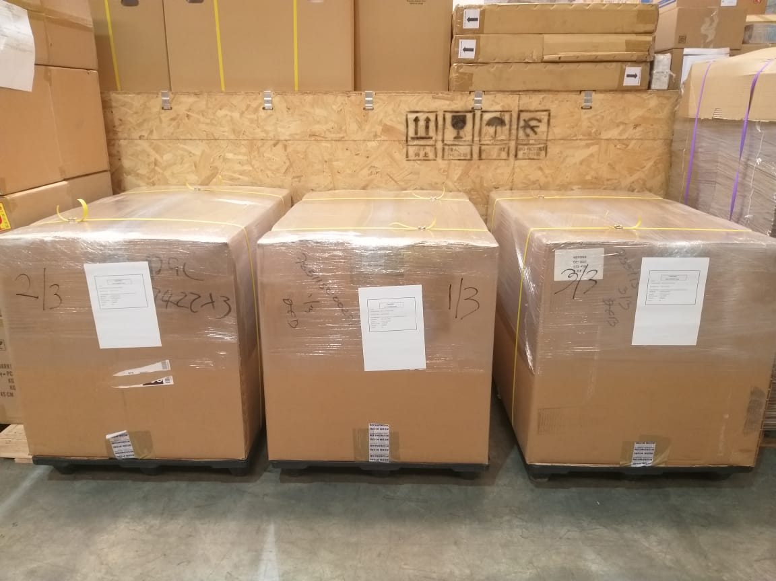 |  | 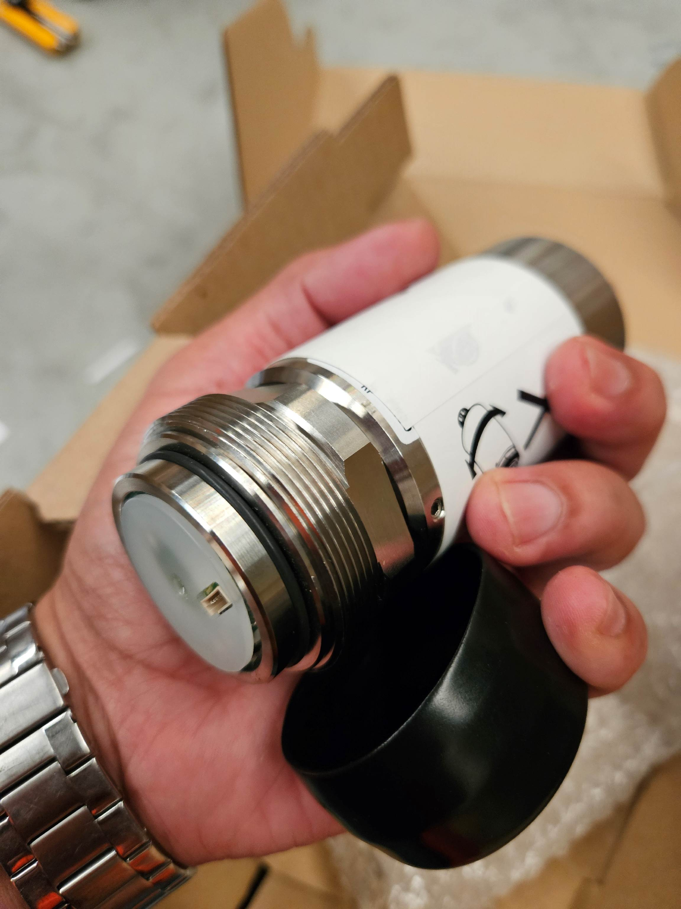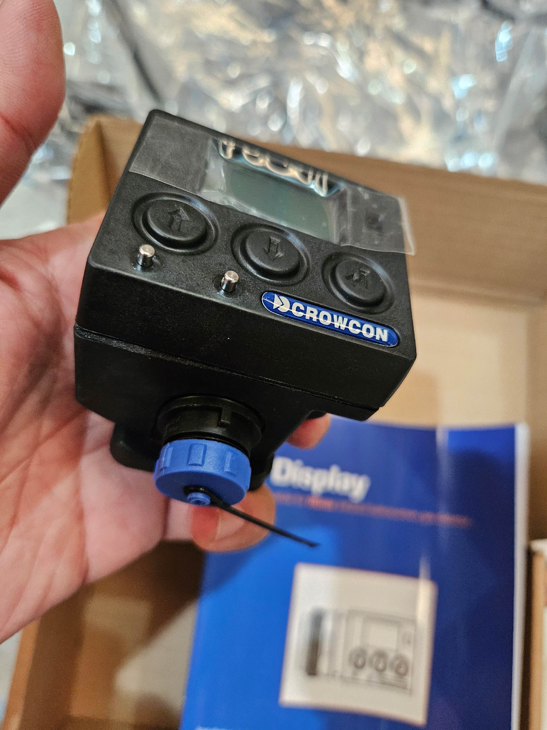
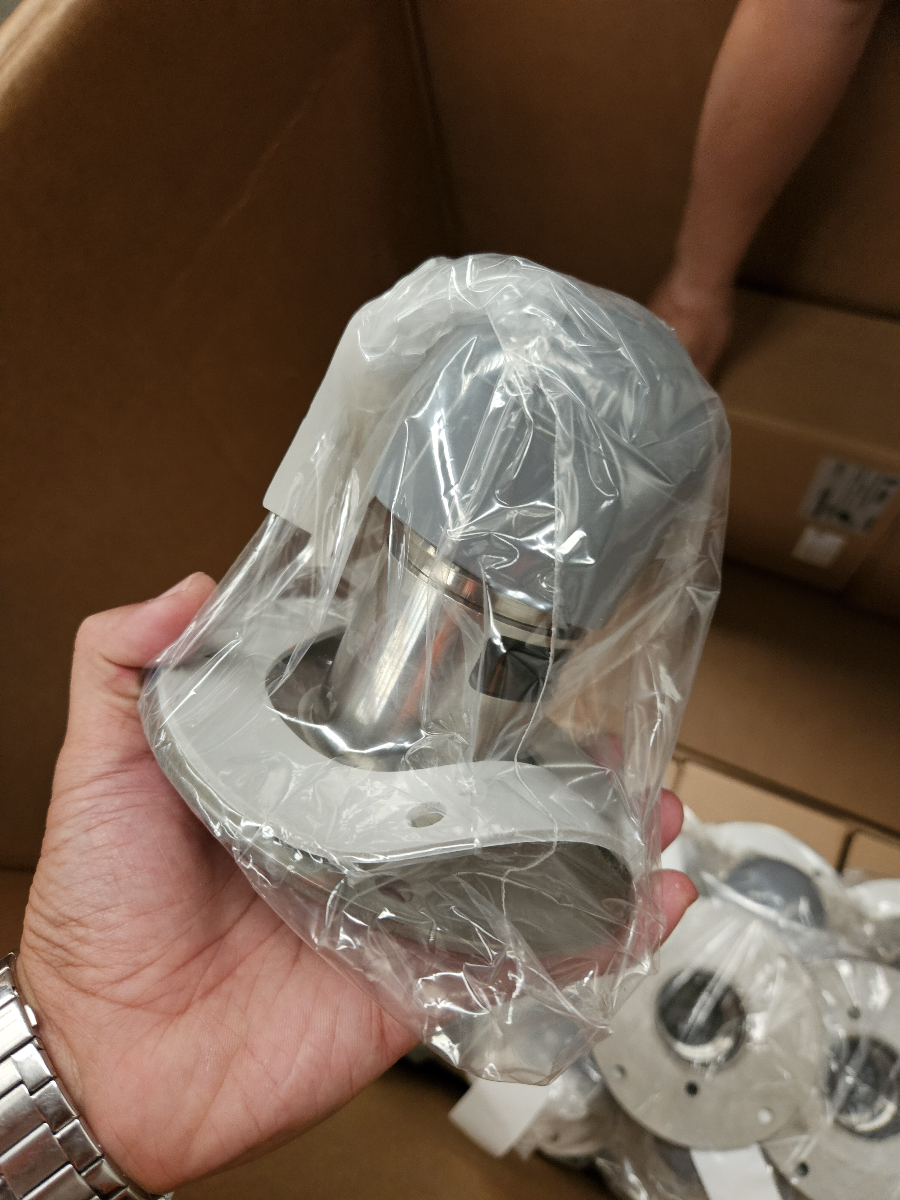 |  | 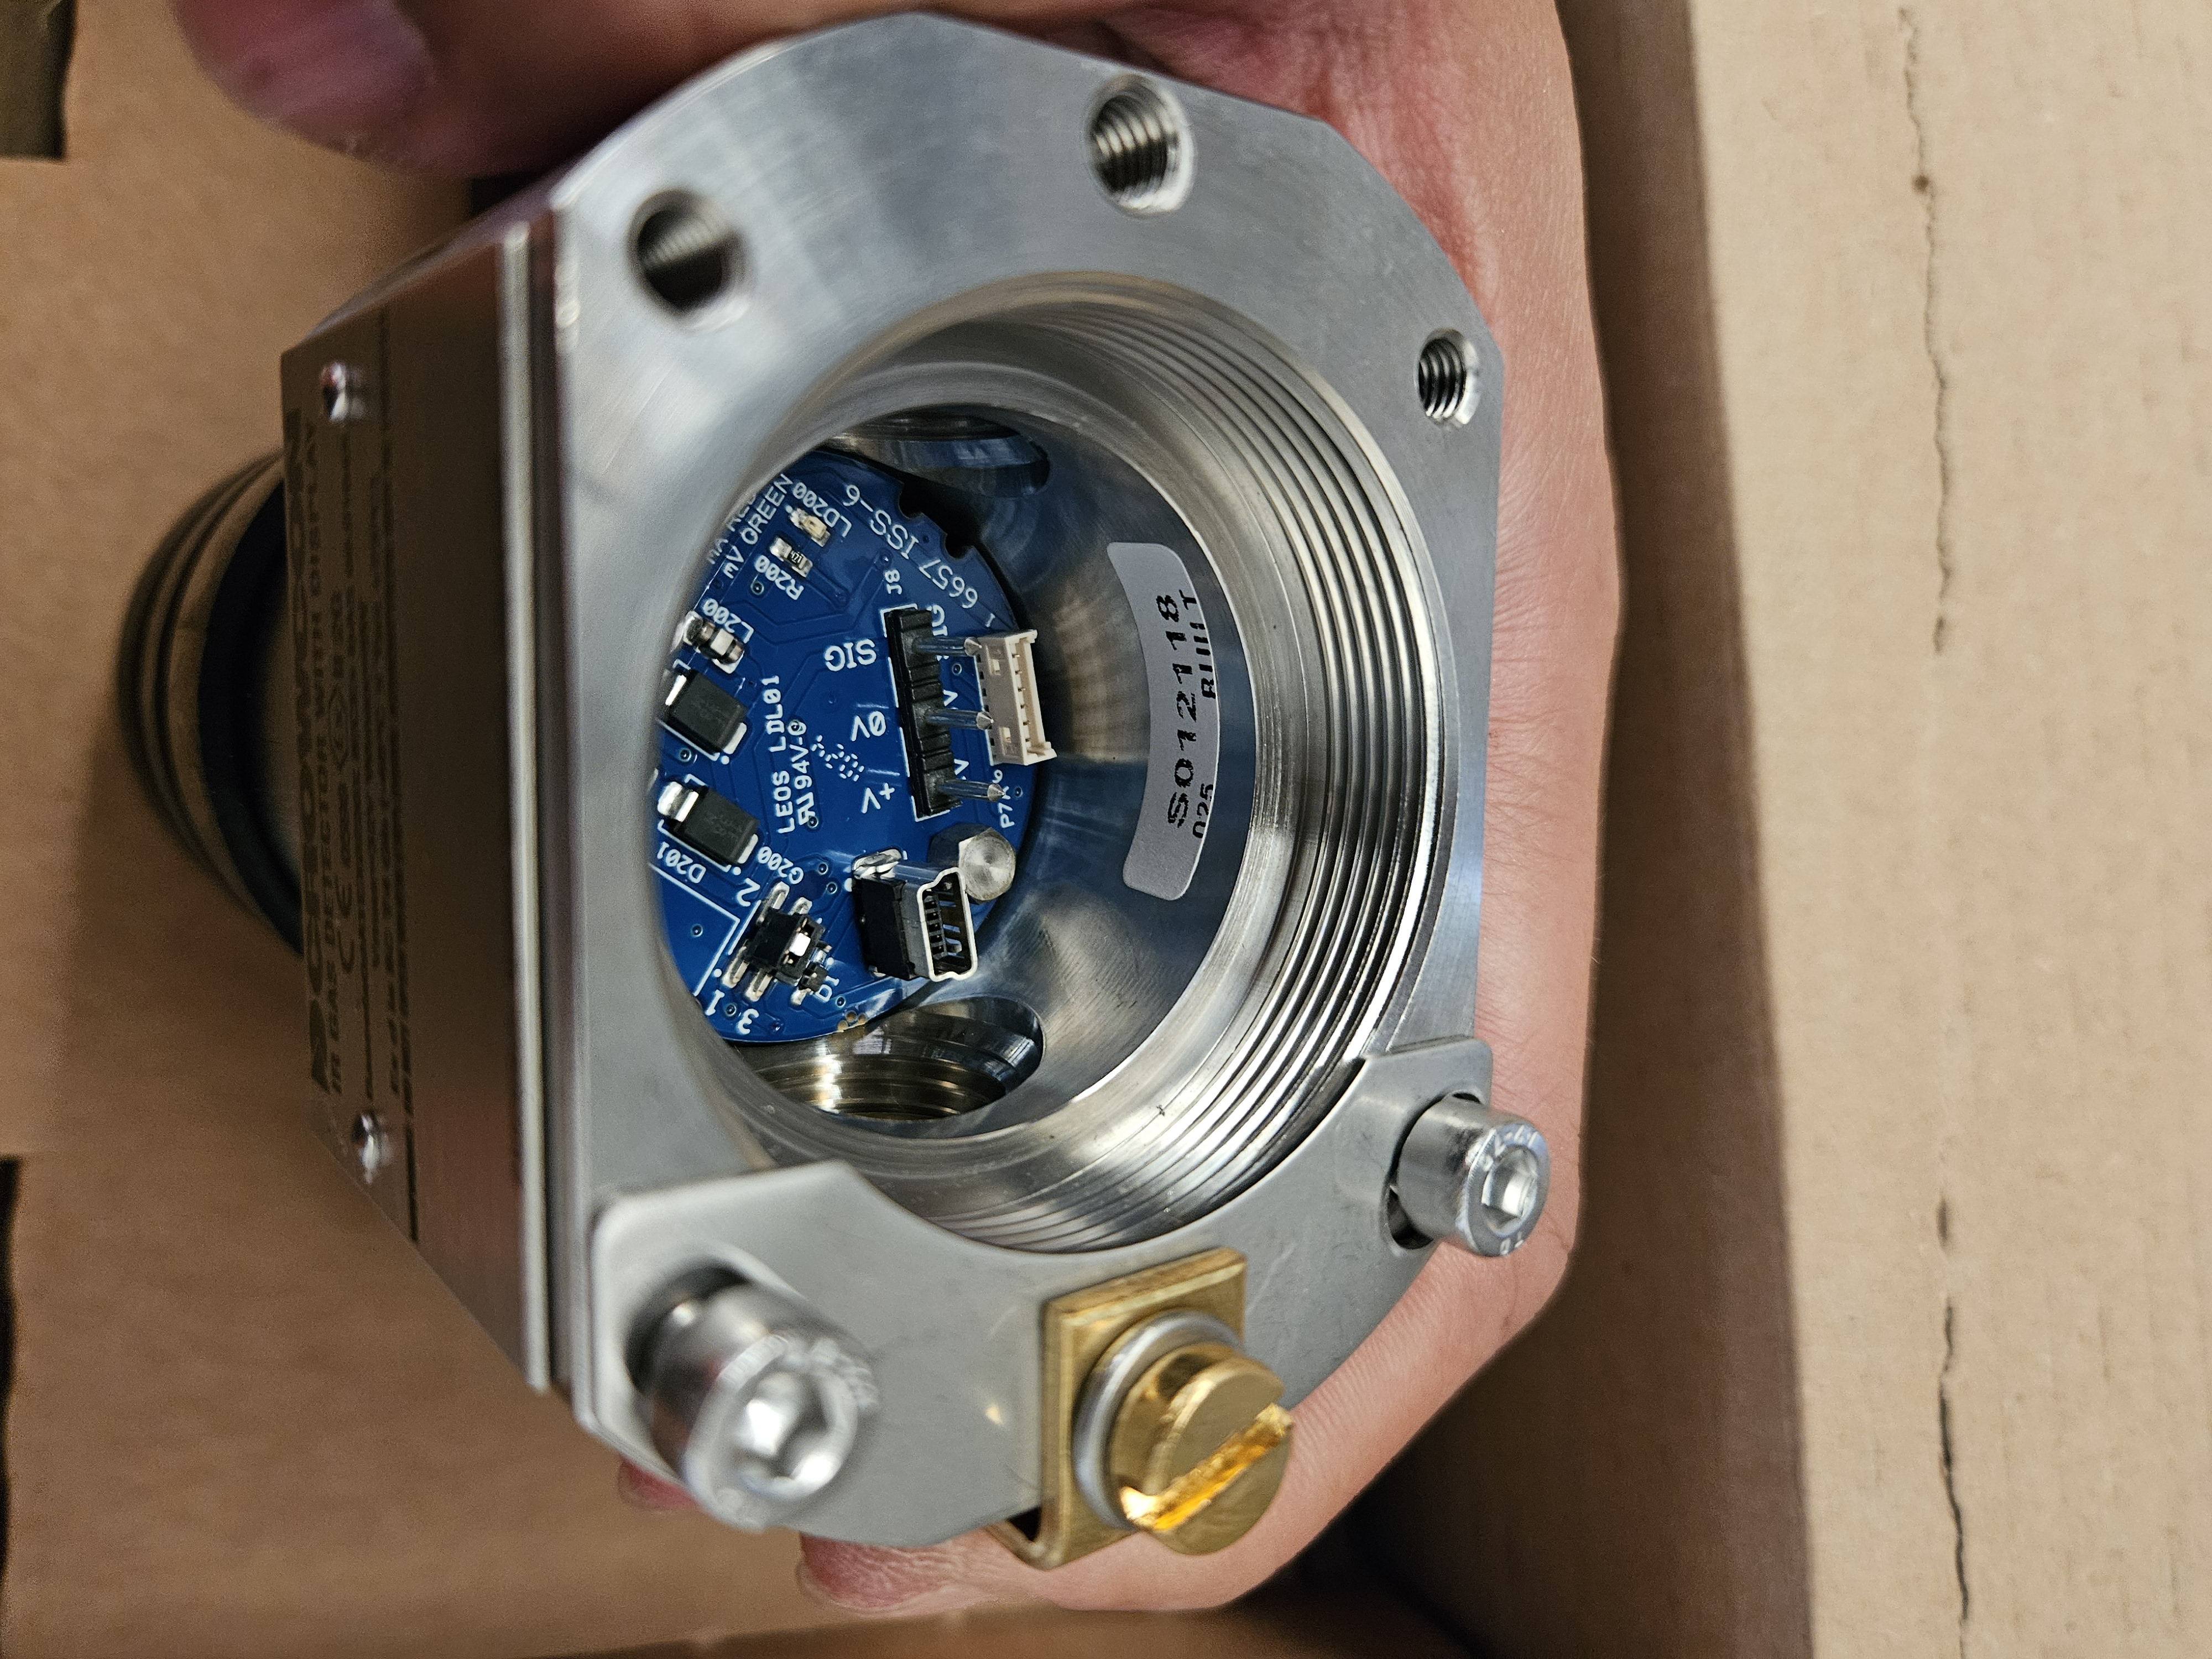
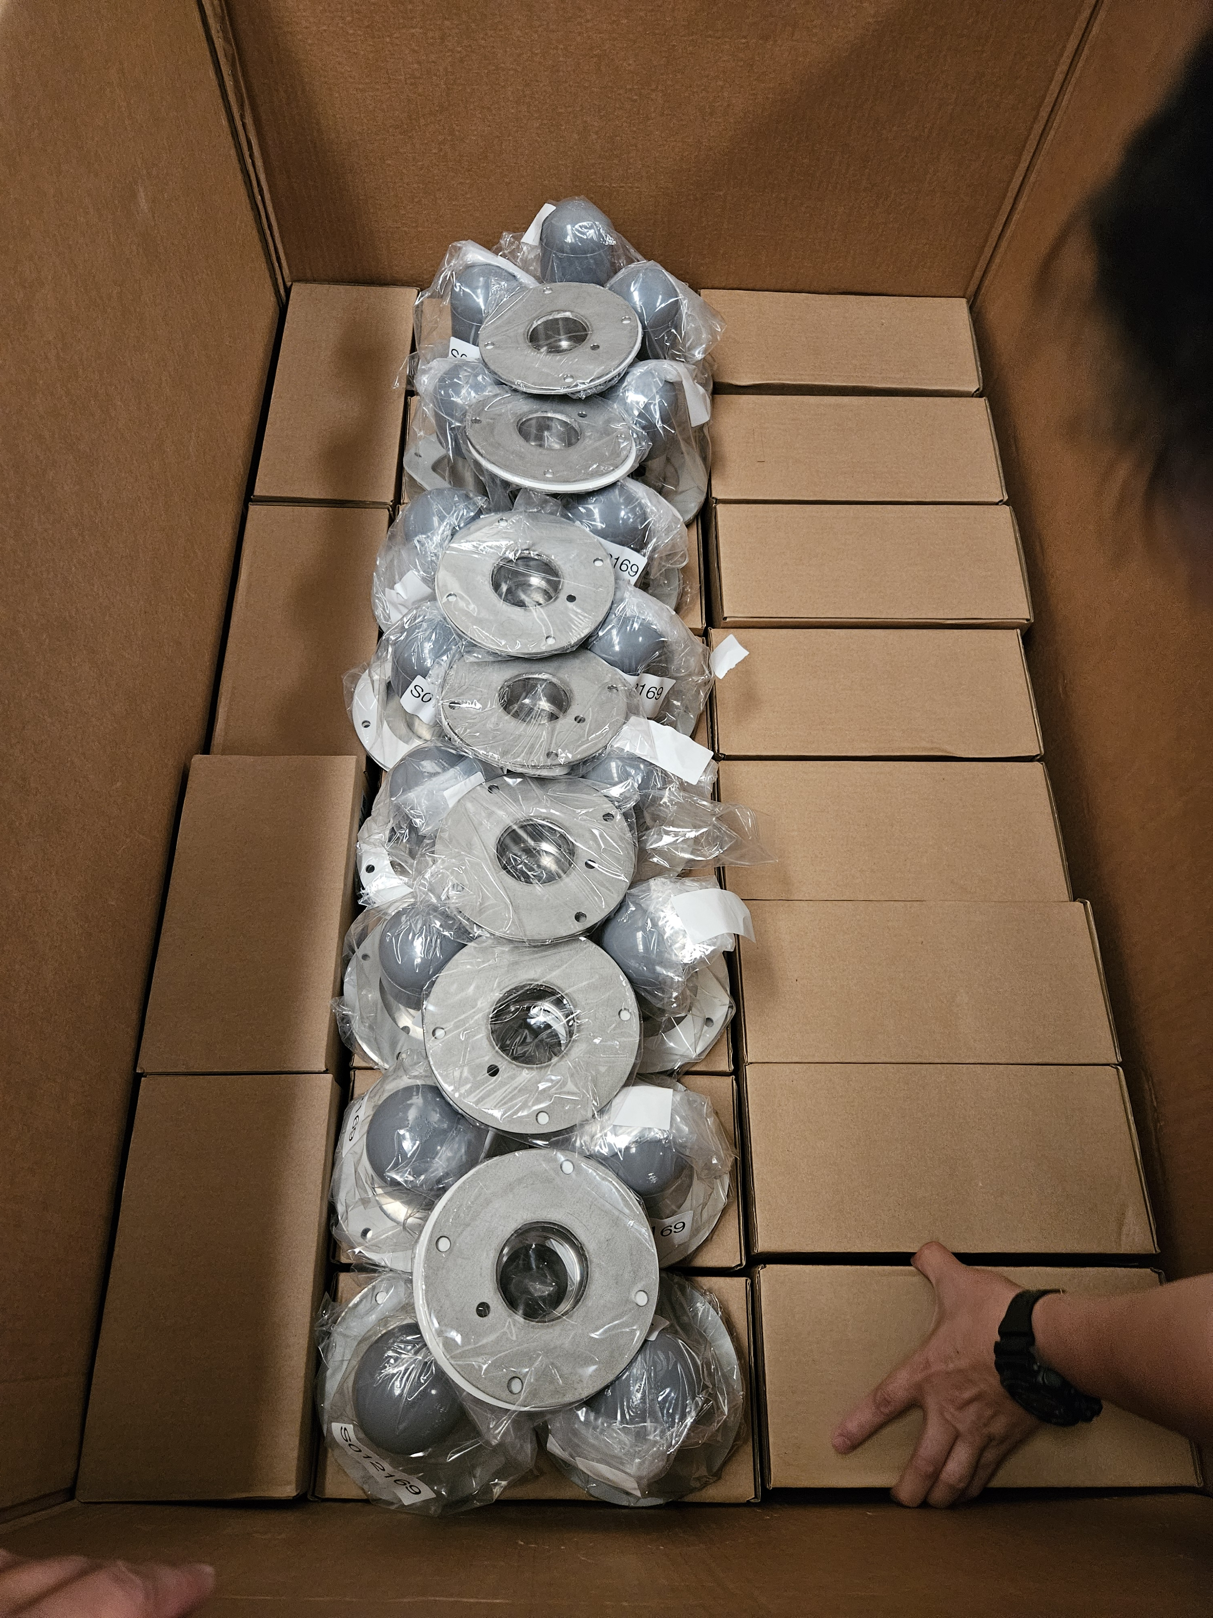 |  | 